 | ABES Engineering College, Ghaziabad  Department of Computer Science & Engineering
Session: 2016-17 Semester: Vth A Student Name: Abhishek Chopra
Subject Code: NCS-502 Subject Name: DBMS Uni. Roll No. 1403210009

Assignment 3: Queries using Group by & Having Clause

Schema: S_ord (CUS_id, date_order, date_shipment, sp_no, total, payment)
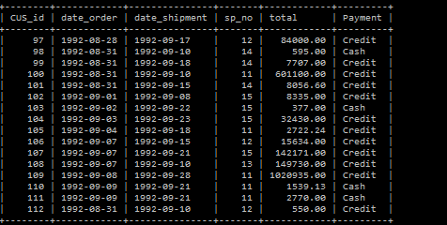

Questions:
- Write SQL query that displays the total and average payments of all the credit orders.
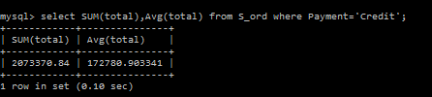
- Write SQL query that displays the total and average payments grouped by type of payment.
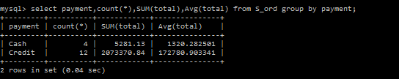
- How many order dates are represented compared to the total number of orders?
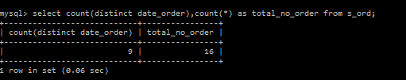
- How many customers and sales representative are represented compared to the total number of orders?
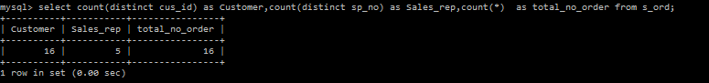

- Write SQL query that displays the lowest and highest payments of all the orders.
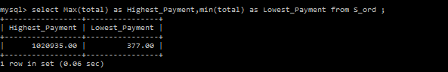

- What is the average amount of the order for each sales representative?
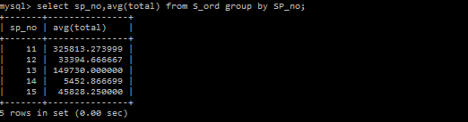

- Write an SQL query to display the order dates and how many orders were on each date.
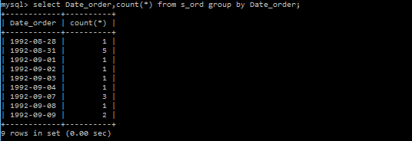
- Write SQL query to display the order amount by payment type for each sales representative.
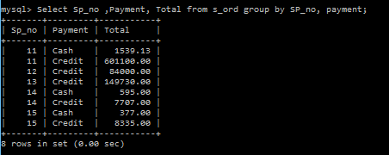
- Query to display the highest and lowest order for each order date where more than one order was placed.
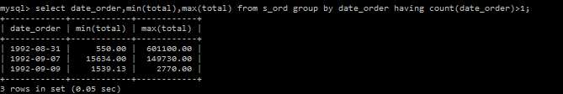
- SQL query to display the average order for each order date where more than one order was placed and the average order is greater than 1000. Display them in order of average order.
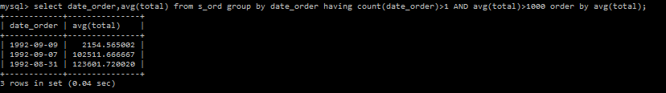

- Display the customer number with more than one order. Arrange alphabetically by customer id.

